Activity No 1.Marketing Club Activity “The Art & Science of Pricing”
Title of the Event | Marketing Club Activity “The Art & Science of Pricing” | 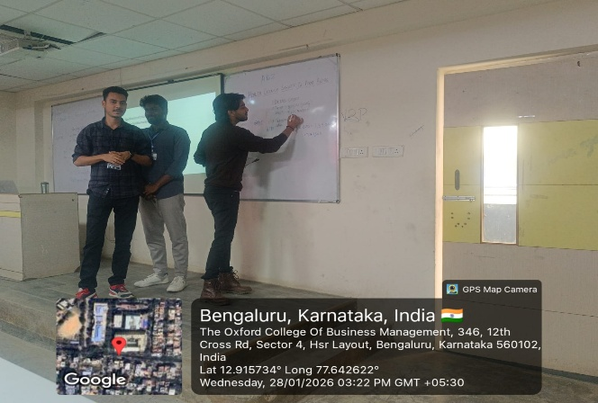
Day and Date | 28.01.2026
Venue (With all details ) | Roon No-309
In collaboration with ( if any) | -
Details of Resource Person With Designation | Dr.Veto Dey | 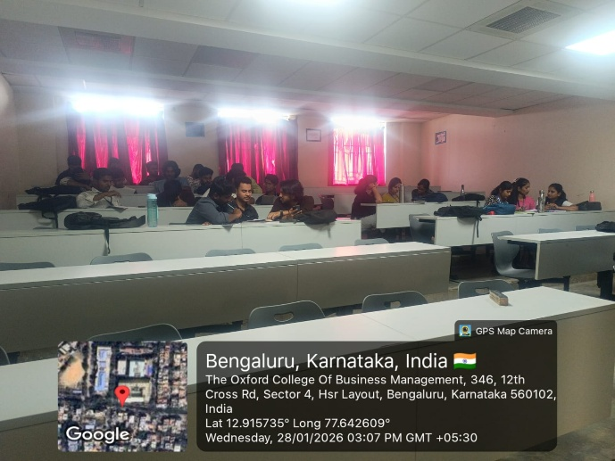
Organizing Department/Coordinators | Business Management . Dr.Veto
Course and semester | MBA I Semester
No of Students & Faculty Participants | 32

Coordinator HoD Vice-Principal Principal

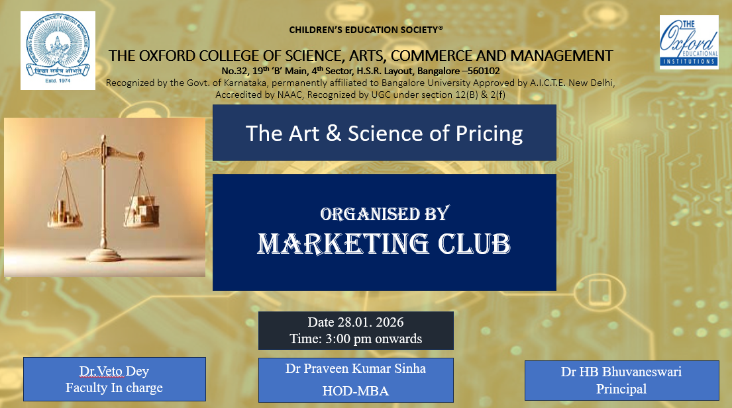

Introduction
Pricing is a vital element of marketing that directly influences consumer behavior and business profitability. To provide practical exposure to pricing concepts, the Marketing Club of the Department of MBA organized an activity on Pricing Strategies “The Art and Science of Pricing” during the club hour.

Description of the Activity
The activity was conducted on 28 January 2026 for MBA students. Students were divided into groups and given product-based scenarios to decide suitable pricing strategies such as cost-based, value-based, and competitive pricing. Each group presented their pricing decisions with proper justification, encouraging analytical thinking and teamwork.

Outcome of the Activity
The activity helped students understand the strategic importance of pricing decisions in marketing. It enhanced their analytical skills, practical understanding, and confidence in applying theoretical concepts to real-life business situations.

Conclusion
The Pricing Strategy activity was an effective learning initiative by the Marketing Club. It successfully connected theory with practice and enhanced student engagement. The Department of MBA will continue to organize similar student-centric activities to enrich learning outcomes.

